**FLOWCHAT FOR AIR QUALITY:**

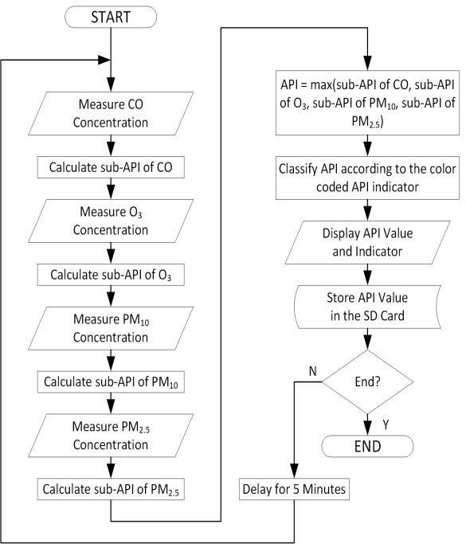

**The use of multi-parameter air quality monitoring systems makes it possible to do a detailed level analysis of major pollutants and their sources.**

**These monitoring systems are important components in many smart city projects for monitoring air quality and for controlling the main pollutant concentrations in urban areas.**